Unit 1 – Notes
Part 3 & 4 (pages 34-55)

Economic Activities and systems of Alliances around 1500

Native Trade Networks

Before contact with the Europeans, most native North Americans had a system of trading alliances already in place.

Great trading networks existed where Native groups would barter (trade) various goods. They used the river systems and forest trails to go very long distances with the items they wanted to trade. Trades often happened where two waterways met. (confluence)

It’s important to remember that the reasons the Native North Americans traded was NOT to gain wealth. It was to satisfy the needs of the people. (subsistence)

Some items that were traded included:
Tobacco, pottery, beans, squash, copper, fur, shells, obsidian, iron, silver

Trading served another purpose as well. Not only was their economic value in it, but it also helped the Native groups establish alliances, or friendships with other Native groups. This allowed them to be trading partners AND Political/Military partners as well. Often trade gatherings also turned into a meeting to discuss politics and diplomacy.

Some alliances actually caused conflict with other Nations. For example, the alliance between several Algonquin nations brought conflict with nearby Iroquois Confederacy Nations. These relations later became further complicated when the French and English started settling the region. (after the year 1500)

The wampum belt, often made of shells and strips of leather was used to document an alliance between nations. Whenever the two sides would meet, the wampum would be shown to serve as proof of a past agreement.

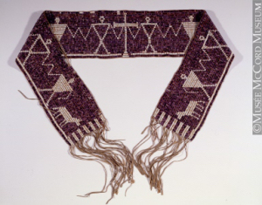
A wampum could be worn as a belt, or around the shoulder, or even around the arms or wrists. Most Eastern North American Native groups used them.

Rivals and War

War often broke out between nations. This was part of their culture. It gave warriors a chance to show their bravery and courage.

During war prisoners were often taken. Many of them were brought back back and killed or tortured. Sometimes, especially in Iroquois nations a prisoner would be adopted into a family to ‘replace’ a deceased family member. (often a daughter or son).

First Contact with Europeans after the year 1500 (16th Century)

In the 1500s Europeans started arriving on the shores of North America. By the 1600’s they were making settlements. The contact they would make with the Native groups in North America would forever change the ways of life of the Natives.

In 1492 Spain sent Christopher Columbus to explore an alternate way to Asia.
In 1497 England sent John Cabot.
In 1524 France sent Giovanni da Verrazano

The Kings of the big European countries spent large amounts of money on explorers. They wanted not only a way to Asia (to get the riches from Asia without going through Turkey and Italy), but they also wanted to set up colonies (a territory that is controlled by a far away Mother Country) in the new land – so that they could collect the riches there as well.

French explorers had 4 objectives:
*find a route to Asia
*create a colonial empire equal to or better than the colonies of other European countries.
*find precious metals to make the king richer
*evangelize the Native people. (make them follow the Catholic religion)

Fishermen, Whalers and trade with Europeans

Some of the first Europeans to come to North America were those who came to Fish Cod (a type of fish) and Whale. They would make their catch/kill, then they would set up temporary camps along North American shores in order to prepare their fish for the long journey back to Europe. This would involve either salting or drying the fish so that it was preserved. (no refrigerators back then!)

Gradually, the Native groups along the shores came into contact with these Europeans. They set up a bartering system. Natives would receive goods made in Europe (glass beads, axes, knives, copper pots, hammers, nails, clothes) and the Europeans would receive furs. These furs soon became a very profitable item to sell in Europe. The Native groups received items that made their lives easier…the Europeans received good that made some of them rich.

This fur trade with the Europeans caused the Native groups to change their ways of life. Many of them who only really hunted in the winter started hunting for furs all year round. They also ended up spending less time fishing. This meant that they had to change what they ate – and their diet became more dependant on the food (flour, dried peas etc) that they received from bartering with the Europeans.

Trading with the Europeans meant that there was less time and resources available to trade between Native groups. This caused stress between members of Native alliances. At times this caused wars between Native groups.

Jacques Cartiers Voyages!

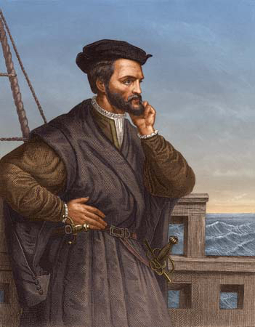
King Francis I of France commissioned Cartier to explore the new land. He sailed on three different occasions:

1534 – Cartier left France with 2 ships On July 24 he set up a cross in Gaspe claiming the territory for the King of France.

1535/36 – Cartier left France with 3 ships. In August he started to make his way down the St Lawerence River. He thought he had found a way to Asia. What he did find was Hochelaga. (now called Montreal). His crew spent the winter in Stadacona (now called Quebec City) for the winter, but 25 of Cartier’s crew members died of scurvy. This winter was also dangerous because fighting broke out between the Iroquois and the French. In May 1536 the crew returned to France.

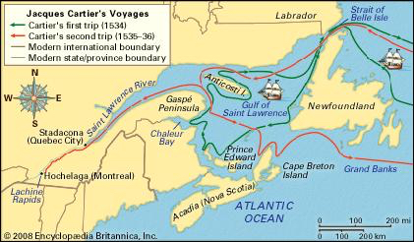

1541 – Cartier set out on his third Voyage. In addition to finding riches, the King of France ordered Cartier to also Evangelize any Native North Americans he could. (teach them and convert them to the Catholic religion). Cartier also brought with him about 400 people to settle the colony and a large amount of provisions to help them set up the colony. They set up a fort close to Stadacona. He called it “Charlesbourg-Royal”

This colony did not last long. In 1543 most of the colonists went back to France because the winter was too hard.

This colonizing failure along with the war in France caused the French to temporarily stop exploration and settlement of the St Lawrence River Valley.

Later attempts by the French to colonize North America

By the the beginning of the 1600’s France wanted to try to colonize and explore North America again. They set up several different colonies:

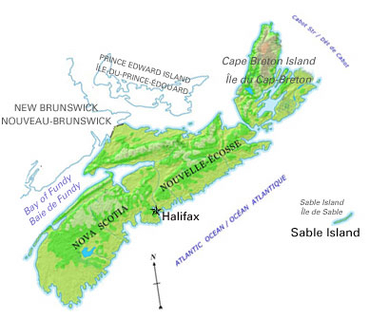
Sable Island – 1598 King Henry IV of France sent Marquis de la Roche out to start a new colony in North America. He chose an Island off the coast of what we call Nova Scotia today. He recruited 60 colonists, mostly beggars and criminals. By 1603 there were only 11 survivors. The Island had almost no vegetation, it was constantly attacked by violent storms and it didn’t get it’s annual promised supplies. The survivors went back to France. Another failed attempt.

Ile Sainte-Croix – In 1603 the King of France sent Pierre Du Gua de Monts out to set up a colony. They landed on and Island in the Bay of Fundy which they called Ile Ste Croix. The first winter was very hard and cold. They lacked supplies.

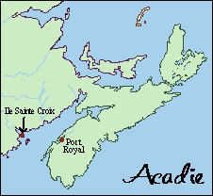
Fort Port Royal – In 1605 the colonists from Ils Sainte-Croix moved to Port Royal. This is in what we call Nova Scotia today. It was destroyed by British forces in 1613, but has been rebuilt and is today a Canadian Historical Site.

Tadoussac – The small trading post of Tadoussac was set up in 1600. This trading post was set up to trade furs with the Native people in the area. The French here learned a lot from the Natives, especially how to survive a winter. This trading post was set up at the mouth of the Saguenay River. By 1603, the French ended up trading with the Innu, Algonquin and Maliseet from this post. This was a perfect relationship as it provided the French with the furs they desired AND it allowed them access to even more Native groups through the alliances of the Innu, Algonquin and Maliseet.

